**Examination Question Bank**

Answers (with explanations) to selected questions to be sent in followup. In the interest of conserving resources, multiple choices questions may be compacted.

1. Which of these is NOT a vesicle that comes off the Golgi?
   1. regulated secretory vesicle
   2. constitutive secretory vesicle
   3. phagosome
   4. lysosome
   5. None of the above
2. A coated pit is a feature of which of these processes?
   1. phagocytosis
   2. pinocytosis
   3. receptor-mediated endocytosis
   4. both (a) and (b)
   5. all of the above
3. A neutrophil engulfs a bacterium by which process?
   1. receptor-mediated endocytosis
   2. exocytosis
   3. phagocytosis
   4. pinocytosis
   5. secreted vesicles
4. Glycolysis is a pathway that starts with which of these biomolecules?
   1. fructose (b) acetyl-CoA (c) pyruvate (d) glucose (e) lactate
5. Glycolysis is a pathway that ends with which of these biomolecules?
   1. carbon dioxide (CO2) (b) acetyl-CoA (c) pyruvate (d) glucose (e) lactate
6. Which of these is not an organelle?
   1. mitochondria (b) nucleus (c) endoplasmic reticulum (d) Golgi apparatus  
      (e) none of the above: they are all of the above are organelles
7. Which of the features below is not part of the smooth endoplasmic reticulum (smooth ER)?
8. ribosomes (b) a phospholipid bilayer membrane (c) lumen (d) cisternae

(e) cytochrome P450 enzymes

1. The electron transport system occurs where?

(a) mitochondrial inner membrane (b) mitochondrial intermembrane space   
(c) mitochondrial matrix (d) cytosol (e) peroxisome

1. In meiosis, in which phase does homologous recombination and the exchange of maternal and paternal DNA (chromosomal crossover)?
   1. prophase I (b) telophase I (c) prometaphase I (d) prometaphase II (e) prophase II
2. In meiosis, in which phase does homologous recombination and the exchange of maternal and paternal DNA (chromosomal crossover)?
   1. prophase I (b) telophase I (c) prometaphase I (d) prometaphase II (e) prophase II
3. Which of these is not found in RNA?

(a) adenine (A) (b) thymine (T) (c) uracil (U) (d) guanine (G) (e) cytosine (C)

1. Which of these is not found in DNA?

(a) 2’-deoxyribose (A) (b) thymine (T) (c) phosphate (d) ribose (e) adenine (A)

1. This structure for coiling DNA takes 6 nucleosomes and forms a coil from them?

(a) nucleosomal chromatid (b) solenoid (c) exon (d) intron (e) nuclear pore

1. Which of these is a FALSE statement?
   1. all protein synthesis happens outside of the nucleus
   2. integral proteins of the plasma membrane are synthesized in the rough ER
   3. the nuclear envelope is continuous with the peroxisomal membrane
   4. all nuclear proteins must be imported through the nuclear pore from cytosol into nucleus
   5. ribosomes dock with the rough ER membrane
2. This class of RNA bonds to the amino acid that is used for translation elongation
   1. messenger RNA (mRNA) (b) transfer RNA (tRNA) (c) ribosomal RNA (rRNA)  
      (d) there is no such RNA (e) the class of RNA exists but not listed
3. This enzyme joins gaps between phosphate and ribose sugar in the DNA strand that may exist after DNA replication or repair
   1. RNA polymerase II (b) RNA primase (c) DNA polymerase III   
      (d) DNA polymerase I (e) DNA ligase
4. The location on the chromosome where a gene is found is called
   1. haploid (b) diploid (c) locus (d) allele (e) centromere
5. In mitosis, these microtubules extending from the aster cause the spindle poles to be pushed further part
   1. chromosomal microtubules (b) polar microtubules (c) astral microtubules  
      (d) all of the above (e) none of the above
6. The onset of the alignment of chromosomes on the spindle equator signals what phase of mitosis?
   1. prophase (b) prometaphase (c) metaphase (d) anaphase (e) telophase
7. This enzyme make DNA strands but cannot remove RNA primers during DNA replication?
   1. RNA polymerase II (b) RNA primase (c) DNA polymerase III   
      (d) DNA polymerase I (e) DNA ligase
8. This term refers to a complete copy of the genetic information of the genetic information of an organism
   1. chromosome (b) chromatid (c) nucleosome (d) genome (e) allele
9. The set of chromosomes in gametes are described as what? (Gametes are _____ cells)
   1. haploid (b) diploid (c) fertilization (d) genome (e) allele
10. What kind of chemical bond is responsible for base pairing in creating double stranded DNA?
    1. polar covalent (b) covalent (c) ionic (d) hydrogen bond (e) van der Waals
11. Which of these is a coupled active transport process?
    1. H2O movement through aquaporin (b) Na/K ATPase activity   
       (c) transport of glucose using Na+ ion concentration difference  
       (d) pumping Ca back into sarcoplasmic reticulum with ATPase (e) all of the above
12. This cell junction would be found between cells that need to stop paracellular transport pathways
    1. desmosome (b) tight junction (c) gap junction (d) adherens junction (e) none of the above
13. What is the term that refers to the many different variations in the sequence of DNA that expresses a trait corresponding to a gene?
    1. haploid (b) diploid (c) chromosome (d) genome (e) allele
14. Knowing that a codon is a triplet of bases (3 bases), how many possible codons are there in the genetic code?
    1. 2 (b) 16 (c) 20 (d) 64 (e) 12,500
15. Which of these is NOT found as a feature of (contained in or part of) the nucleus?
    1. nuclear envelope (b) nucleolus (c) chromatin (d) Golgi   
       (e) pre-messenger RNA (pre-mRNA)
16. This structure for coiling DNA uses 8 highly basic (positively charged) polypeptides?

(a) nucleosome (b) solenoid (c) exon (d) intron (e) nuclear pore

1. Which of these is a factor determining the melting temperature (Tm) of a double-stranded DNA oligonucleotide?

(a) number of exons (b) number of introns (c) number and proportion of GC and AT pairs  
(d) number of nuclear pores (e) Golgi processing

1. What is the term that corresponds to a genotype having the same alleles, such as *BB*?
   1. haploid (b) diploid (c) nuclear (d) homozygous (e) heterozygous
2. The onset of the breakdown of the nuclear envelope signals what phase of mitosis?
   1. prophase (b) prometaphase (c) metaphase (d) anaphase (e) telophase
3. Which of these involves GTP binding to a protein subunit?
   1. receptor tyrosine kinase activation by growth factor ligands
   2. G protein-coupled receptor activation
   3. steroid hormone receptor activation
   4. both (a) and (b)
   5. all of the above
4. This enzyme is required for transcription of messenger RNA (mRNA)
   1. RNA polymerase II (b) RNA primase (c) DNA polymerase III   
      (d) DNA polymerase I (e) DNA ligase
5. One turn of the TCA cycle produces how many carbon dioxide (CO2) molecules?
   1. 0 (b) 1 (c) 2 (d) 3 (e) 6
6. What is catabolism and anabolism?
7. From one glucose molecule, fill in the table below. Note that “ATP or GTP” can be substrate level phosphorylation for glycolysis and TCA, and oxidative phosphorylation level for ETS

|  |  |  |  |
| --- | --- | --- | --- |
| Produced | Glycolysis | TCA (Krebs) Cycle | Electron Transport System |
| NADH |  |  |  |
| FADH2 |  |  |  |
| ATP or GTP |  |  |  |
| CO2 |  |  |  |

1. What type of cell in the bone forms bone and is reduced in osteoporosis?
2. What is the name of the proteoglycan found in abundance in the intervertebral disc?
3. Translational elongation repeats 3 steps: (1) Decoding (2) Transpeptidation and (3) Translocation. Briefly describe what happens in all three steps. Your answer should include mention of the sites in the ribosome (P, E, A) and how tRNA and mRNA are involved.  
     
   (1) Decoding  
     
     
   (2) Transpeptidation  
     
     
   (3) Translocation
4. 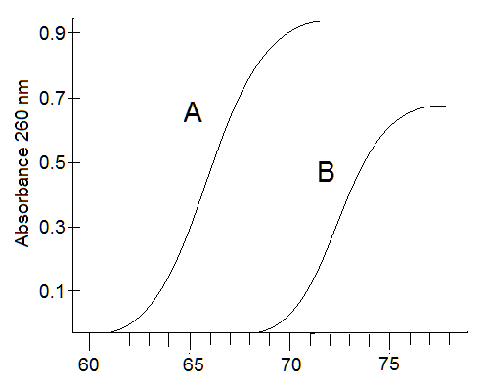The following are related to the figure at right

(a) Estimate the melting temperature (Tm) of ds DNA oligonucleotide A ____ (hint: draw lines on the graph to show your thought process)

* 1. Estimate Tm for oligo B ______
  2. If both oligos have the same number of base pairs, which oligonucleotide has the higher %AT content?

Yes, another factor affecting the Tm is the number of base pairs: if two oligos have the same %GC-%AT content. the longer oligo, i.e. has more base pair counts, will have a higher Tm.

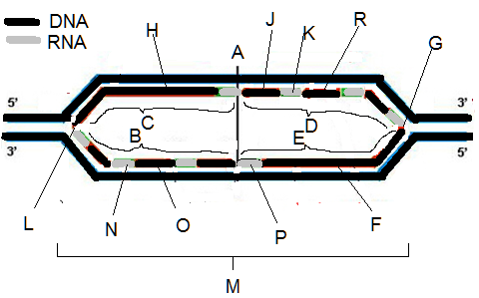A scientist is designing oligonucleotides for a PCR-based diagnostic test for cancer

There may be several possibilities for answers below in the diagram above. You only need enter one answer.

1. ___ newly made DNA
2. ___ RNA primer
3. ___ replication bubble
4. ___ replication fork
5. ___ leading strand
6. ___ lagging strand
7. ___ replication origin

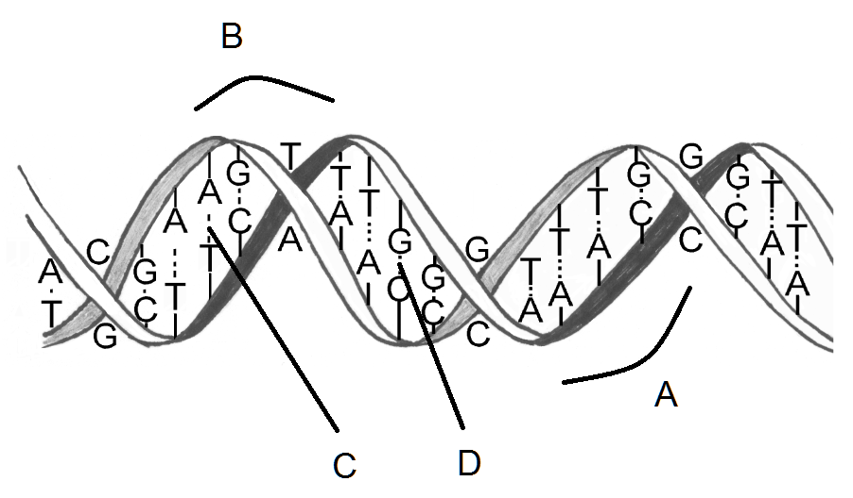In the figure at right, you see the double stranded DNA helix  
  
What is the spacing shown by A called?  
  
What is the spacing shown by B called?  
  
What are the number of bonds between the GC base pair shown in D?  
  
What are the number of bonds between the AT base pair shown in C?  
  
What is the name of the type of DNA that has the classical right-handed helical twist?  
  
What is the name of the type of DNA that has a zig-zag left-handed twist and is thought to be a transcriptionally inactive form?

1. Which of these is the name for the process in which RNA is made?
   1. replication
   2. recombination
   3. **transcription**
   4. translation
   5. none of the above

Explanation: The Central Dogma of gene expression is that DNA is transcribed to make RNA and that RNA is translated to make protein, so RNA is made from DNA by a process termed transcription while polypeptides (protein) are made from the RNA by a process termed translation. Replication is about a copy of the DNA made into DNA, usually for the purpose of making new cells and ensuring they get a proper copy of the genome. Recombination is the process that occurs in prophase of meiosis I to create genetic variation in gametes, in which DNA from homologous chromosome pairs is aligned and the DNA strands broken and re-joined in an exchange process.

1. A ribosome would be used in which of these processes?
   1. replication
   2. recombination
   3. transcription
   4. translation
   5. none of the above

Explanation: A ribosome is an assembly of two subunits that are called the 40 S subunit (small) and the 60 S subunit. [Note those terms 40S and 60S come from a property of these subunits in that they can be pelleted in an ultracentrifuge and these numbers reflecting the rate at which these macromolecules sediment in the centrifuge.] Each subunit is composed of RNA polynucleotides around which several dozens of proteins are wrapped. It is particularly in the large subunit that tRNA molecules enter attached with one amino acid to the A site with a match of mRNA codon to tRNA anticodon, and the tRNA already in the P site transfers its chain of amino acids (existing polypeptide) to the tRNA with its single amino acid in the A site (using GTP to provide energy source), and then the ribosome is moved the length of a codon (3 bases) using GTP energy again, and the P site tRNA (now having no polypeptide chain) enters the E site and falls away while the tRNA in the A site with the nascent polypeptide chain moves into a the P site. The ribosome thus mediates this process and participates in elongation in **translation**. Don’t neglect that the ribosome will be assembled on the mRNA starting with the small 40S subunit and an initiating tRNA with a methionine (Met) amino acid attached, and this will slide along the mRNA up to the start codon which is the sequence AUG.

1. Which of these is NOT required for translation?
   1. m7G-cap on 5’ end of mRNA
   2. poly(A) tail on 3’ end of mRNA
   3. 40S ribosomal subunit
   4. AUG codon
   5. **all of the above are required**

Explanation: items (a) and (b) are features of the fully processed mRNA molecule, and must be on the molecule for the mRNA to be translated. Item (c) is required through initiation and elongation of translation. Item (d) is required to know where the start of translation is. So all are required.

1. Which of these is a DNA sequence that is used to locate the start of transcription?
   1. transcription factor
   2. m7G 5’ cap on mRNA
   3. **promoter**
   4. exon
   5. intron

Explanation: The promoter is a DNA sequence that determines the location of the start of transcription. DNA-binding proteins called transcription factors recognize the promoter sequences and bind to the DNA helix, and other binding domains on these transcription factors recognize RNA polymerases, the enzymes that polymerize RNA from the DNA, and direct the RNA polymerases precisely to the transcriptional start site. Many other transcriptional factors will come in and create an initiation complex that opens the double strand to form a single strand in the DNA, and the RNA polymerase will start polymerizing RNA (transcribing) off the DNA strand.

BY THE WAY the Lecture 18 slide on protein synthesis that told you that the RNA was synthesized by pairing (forming a complement) with the **coding strand** was in error. The synthesized RNA to become the mRNA will have the same sequence as the DNA **coding strand**, and this can only be true for the DNA strand which is NOT read (touched) by the RNA polymerase. It is the **noncoding strand** that the RNA polymerase actually uses (touches) to create the 5’🡪3’ RNA polynucleotide. This nomenclature has even caused confusion for molecular biologists, so they have tried to change the nomenclature by referring to the noncoding strand as the template strand instead. This has created far less confusion

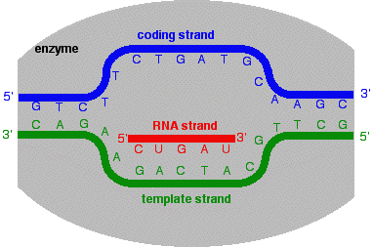 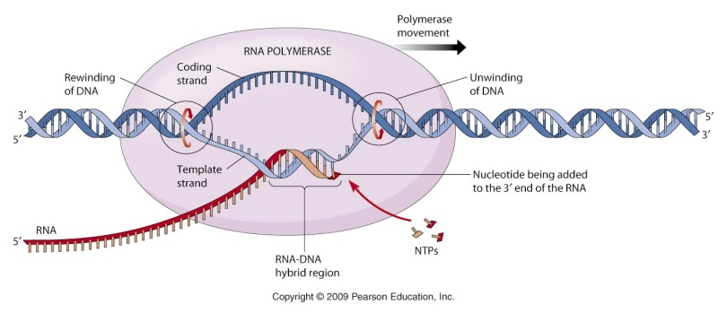

1. Which of these is a protein?
   1. **transcription factor**
   2. m7G 5’ cap on mRNA
   3. promoter
   4. exon
   5. intron

Explanation: From the answer above, it has already been explained that transcription factors are DNA-binding proteins that match promoter position to RNA polymerase position, in addition to doing other things that transition transcription from initiation to elongation. The 5’ cap on mRNA is actually a nucleotide on the 5’ end of an RNA polynucleotide (although a specially modified one). A promoter is also a nucleotide (DNA) sequence, so not a protein. Exons and introns are features of messenger RNA, so also not proteins.

1. The scanning of the 40S ribosome complexed protein factors and with tRNAMet to an AUG code is involved in what process?
   1. transcription initiation
   2. translation termination
   3. **translation initiation**
   4. transcription termination
   5. translation elongation

Explanation: The details of the initiation of translation include proteins called initiation factors complexing with the small 40S ribosome and the tRNAMet which has the anticodon that matches the AUG codon (coding for methionine or Met amino acid), in addition to binding to the mRNA. With this complex formed, the mRNA is “scanned” until it finds the matching AUG codon. Then the rest of the ribosome is assembled and there is a transition into elongation. There is no transcription involved (no RNA is being made), and the process does not at all describe the other events in elongation and termination of translation.

1. A release factor called eRF1 enters the A site of a ribosome and hydrolyzes the nascent polypeptide in what process?
   1. transcription initiation
   2. **translation termination**
   3. translation initiation
   4. transcription termination
   5. translation elongation

Explanation: Termination of translation involves a special protein (yes it is a protein) called eRF1, or eukaryotic release factor 1. This eRF1 has the ability to recognize stop codons, and it sets up a process that cleaves the polypeptide (C-terminal end) off the tRNA in the P site of the ribosome. The polypeptide diffuses away. Later other proteins will come in to disassemble the ribosome so it can start a new translation.

1. The exons in a gene have 30% C. Which of the following below is true about the mature mRNA?
   1. it will be 20% G
   2. it will be 30% A
   3. **it will be 20% U**
   4. it will be 30% T
   5. cannot be determined from the information given

Explanation: Exons are the parts of the gene (remember the gene is encoded in the DNA) that will go to forming the mature mRNA after splicing out of the introns. So if the mature mRNA is 30% C, then it must be 30% G. This means the other two bases are 20% A and 20% U (recall that T is not a base in RNA). Based on all these determinations, (a), (b) and (d) should be eliminated as false, and (c) is true. (e) is false because one of the options was true.

1. Which of these is a TRUE statement?
   1. DNA is synthesized in the 5’🡪3’ direction
   2. RNA is synthesized in the 5’🡪3’ direction
   3. In some cases RNA is synthesized in the 3’🡪5’ direction
   4. **(a) and (b)**
   5. all of the above are true

Explanation: This question is intended to emphasize that all these polynucleotide syntheses (polymerizations) are with enzymes that bind the template strand and move by adding new bases complementary to (pairing with) that template strand in the 5’🡪3’ direction, whether making DNA or RNA. I know of no enzyme or biological phenomena where synthesis is in the opposite direction. Items (a) and (b) must therefore be true. Item (c) is intended to make you ponder, but it is ultimately false. Since (a) and (b) are true, (d) must be the best option.

1. Where will you find Coenzyme Q?
   1. as an electron carrier in TCA cycle
   2. used in a reaction with glucose in glycolysis
   3. as a cofactor in the pyruvate dehydrogenase reaction forming its 2-carbon product
   4. involved with interacting with RNA polymerase in transcription
   5. **none of the above**

Explanation: No, Coenzyme Q is not found on the shelves of these stores that purvey St John’s Wort or ginkgo biloba. Coenzyme Q is a lipid-soluble quinone (hence the Q) embedded in the mitochondrial inner membrane and the redox link (electron transporter) between NADH dehydrogenase (Complex I) and the cytochrome c reductase (Complex III) as well as the link between succinate dehydrogenase (with its FADH2 coenzyme) (Complex II) and the same Complex III. We did not get into the details of the complexes though (to be learned in a detailed biochemistry class; see the figure below). It is not part of the TCA cycle since that happens in the matrix. It has no relation with glucose in glycolysis. It is not a cofactor in pyruvate dehydrogenase: that is Coenzyme A, not CoQ, and the 2-carbon product is acetyl-CoA (had I given that, that would have been a strong clue). And it has nothing to do with RNA polymerase or transcription. Item (e) was the correct choice.

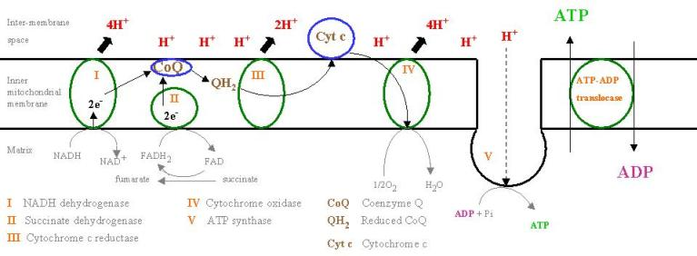.

1. Where will you find Coenzyme A?
   1. as an electron carrier in TCA cycle
   2. used in a reaction with glucose in glycolysis
   3. **as a cofactor in the pyruvate dehydrogenase reaction forming its 2-carbon product**
   4. as an oxidation-reduction component in the electron transport system (ETS)
   5. none of the above

Explanation: Given the explanation from the previous question, this should be the right choice.

1. The space within the endoplasmic reticulum is called the
   1. **lumen** (b) pore (c) cisternae (d) cytosol (e) vesicle interior

Explanation: The terms for the various parts / structures for the ER were discussed. The cisternae is the plural defined as being the flattened stack of membranous stacks of the ER, a term also used to describe the Golgi apparatus. No term for pore was described for the ER, but was for the nuclear envelope, with which the ER is continuous. Which vesicles form from the ER, they become distinct from it, usually on their way to the Golgi. Note that the lumen is segregated from the cytosol.

1. The Golgi apparatus is made up of a stack of enclosed flattened membranous sacs called
   1. lumen (b) pore **(c) cisternae** (d) cytosol (e) vesicle interior

Explanation: Well now this seems to have been explained in the previous answer.

1. Which of these integral membrane proteins would be crucial to producing a neuronal resting membrane voltage potential?
   1. Na+/glucose symporter (b) sarcoplasmic reticulum Ca-ATPase **(c) Na+/K+ ATPase**  
      (d) protein kinase A (e) G-alpha (G) subunit

Explanation: It seems this was discussed exhaustively during the course. The Na/glucose symporter was actually about a protein found in the kidney to recover glucose that was passed into the fluid of the kidney tubule through glomerular filtration. The calcium ATPase is about getting Ca2+ out of the cytosol and into the sarcoplasmic reticulum so that muscle contraction can be halted. The protein kinase A (PK-A) is involved in signal transduction, and it might be involved in modulating membrane voltage potentials but it has no role in “producing” them. The G-alpha subunit is not involved in ion pumping, but again in signal transduction to alter cell physiology/role.

1. Which of these integral membrane proteins is used to transport Ca2+ out of a muscle cell to stop its contraction?
   1. Na+/glucose symporter **(b) sarcoplasmic reticulum Ca-ATPase** (c) Na+/K+ ATPase  
      (d) protein kinase A (e) G-alpha (G) subunit

Explanation: Addressed in previous answer.

1. Which of these proteins is involved in signal transduction and phosphorylates other proteins?
   1. Na+/glucose symporter (b) sarcoplasmic reticulum Ca-ATPase (c) Na+/K+ ATPase  
      **(d) protein kinase A** (e) G-alpha (G) subunit

Explanation: A kinase is an enzyme that uses ATP to put phosphate on its substrate (and also forms ADP as a product). A protein kinase is an enzyme (also a protein) that uses ATP to put a phosphate on a substrate that is a protein. With the other “just kinase,” the substrate does not have to be a protein. Protein kinase A fits that description, and it is involved in signal transduction. That distinguishes it from the G-alpha subunit, also involved in signal transduction, but which is not something that phosphorylates proteins.

1. You observe a cell under high magnification of a phase-contrast microscope forming a cupped invagination with no pseudopodia and form an internalized vesicle?
   1. regulated secretory exocytosis (b) constitutive secretory exocytosis **(c) pinocytosis**  
      (d) phagocytosis (e) exocytosis

Explanation: No pseudopodia: eliminate phagocytosis (d). Invagination leading to internalized vesicle, so it eliminates any exocytosis process (a) and (b) and (e) (option (e) should have been receptor-mediate endocytosis…oh well). Cupped-shape invagination…best fits pinocytosis.

1. A glycoprotein will get a sulfate (SO42–) group on its glycan (oligosaccharide) sugar portion: where will this happen?
   1. plasma membrane (b) mitochondria **(c) Golgi apparatus**   
      (d) rough endoplasmic reticulum (e) peroxisome

Explanation: One of the presentations talked about sulfation of glycoproteins and glycosaminoglycans forming proteoglycans. This is done using an activated (high energy) form of sulfate called PAPS. Indeed ATP is an activated (high energy) form of phosphate, and so the similarity of activating molecules in this way to be transferred as chemical groups to biomolecules follows this model. Anyway, this presentation was on the Golgi apparatus, so the correct answer is the Golgi.

1. A lysosome fused with a phagocytic vesicle. Which of these is FALSE?
   1. the lysosome contain proteins and other molecules that have digestive properties or chemical reactions that break down what is in the phagocytic vesicle
   2. **the pH within the vesicle will increase**
   3. the resulting vesicle has membrane protein transporters that are proton (H+) ATPases and will move H+ from the cytosol into the vesicle
   4. both (a) and (b)
   5. none of the above: all of the above are true

Explanation: I hope this is not seen as a gotcha question. It checks your analytical powers. Item (a) is true: the lysosome will be filled with proteins and other biomolecules that break down what’s inside. Item (c) is true: it was discussed that protons (H+) are pumped into the vesicle from the cytosol. So if the hydrogen ion concentration [H+] is increasing in the vesicle to make it more acidic, then the pH must decrease and not increase, as a lower pH is more acidic. This comes from the lecture where the definition of the pH was discussed. Additionally one or more of the presentations discussed pH values as well. So you should always be aware of how the pH relates to [H+].

1. Which of these is NOT an example of receptor-mediated endocytosis?
   1. diphtheria bacteria exploiting this process to make cells take up their toxin
   2. **the cell bringing in glucose for glycolysis**
   3. LDL receptors taking in LDL particles to obtain cholesterol
   4. cells importing vital iron ion (Fe3+)
   5. all of the above are example of receptor-mediated endocytosis

Explanation: Three example of receptor-mediated endocytosis were given in lecture, and they correspond to items (a), (c), and (d), and you are asked to find something NOT described by this process. This clearly corresponds to choice (b). Glucose is brought into the cell by a facilitated diffusion process, with a glucose transporter in the plasma membrane. This glucose transporter in some cell types must actually be switched on to allow transport: this is true of cells that are insulin-dependent such as liver, adipose tissue and skeletal muscle: insulin must bind to its receptor on the plasma membrane of these cells, and then a signal transduction process tells the glucose transporter in the plasma membrane to allow glucose in, but only by diffusion, not by an active transport process.

1. This has its own DNA, which is small and circular
   1. plasma membrane **(b) mitochondria** (c) Golgi apparatus   
      (d) rough endoplasmic reticulum (e) peroxisome

Explanation: In lecture, mitochondria were discussed as having a small circular DNA…its own limited genome. It has been hypothesized that mitochondria were free-living organisms in some form that became endosymbionts as part of a larger cell that may have existed anaerobically: recall that glycolysis can proceed to making ATP without the functions of the mitochondria, which end up making much more ATP when oxygen utilized. As hundreds of millions of years passed, the endosymbiont became quite interdependent: not all the enzymatic functions of mitochondria are coded in its own genome, but in the nuclear genome. It is also interesting that plant cells have both mitochondria and chloroplasts. Like mitochondria, chloroplasts are membranous organelles with their own single circular DNA and genome, and like mitochondria, chloroplasts generate H+ gradients across membranes and use them to drive the synthesis of ATP, except mitochondria use NADH and FADH2 from glucose catabolism as an energy source, and chloroplasts use the energy of sunlight.

1. Catalase is an enzyme that does what?
   1. it corrects problems in DNA
   2. it removes a potentially dangerously reactive chemical called superoxide anion (O2–)
   3. **it removes a potentially dangerously reactive chemical called hydrogen peroxide (H2O2)**
   4. it is one of components of electron transport system that moves protons (H+) across inner membrane
   5. It uses 3 protons (H+) to create one ATP molecule in the mitochondria

Explanation: The enzymes catalase and superoxide dismutase (SOD) were discussed as enzymes necessarily evolved to help cells cope with the bargain made to extract the high amount of energy from fuel biomolecules in a reaction with molecular oxygen (O2) at the risk of generating products that are highly reactive and destructive. The chemistry of oxygen is such that it will take electrons one at a time to fill up its molecular orbitals and this allows O2 to form superoxide anion O2– (really a free radical) or to form hydrogen peroxide (HO**:**OH) which can undergo hemolytic cleavage to form hydroxyl free radicals (•OH), all reactive oxygen species (ROS). These molecules react with whatever’s around them, and in particular DNA, potentially causing mutagenesis and cancer. Curiously some medications such as chemotherapeutics (anti-cancer drugs) are used to promote the generation of ROS within cancer cells so that their buildup can kill the cell. Cells contain catalase however, which acts on HO**:**OH (H2O2) to form benign products (H2O, O2), and SOD, which acts on O2–, which forms H2O2 and O2, with catalase handling its peroxide product.

1. Exocytosis involves a very important substance entering the cytosol from the extracellular medium to activate proteins involved in fusing the membrane of vesicles to the plasma membrane: what is that?
   1. glucose
   2. phosphate ion (Pi)
   3. **calcium ion (Ca2+)**
   4. sodium ion (Na+)
   5. potassium (K+)

Explanation: Many cells have evolved so that when the ***cytosolic*** concentration of calcium ion (Ca2+), the ion binds many proteins within the cytosol and the *function* of that protein is changed. It may be to turn the function of that protein ON when it was previously in the OFF state (qualitative state change). It may be to turn a protein OFF when it was previously in the ON state. It may be to ramp up (increase) the activity of a protein whose activity was at a lower level (quantitative state change) or conversely to ramp down that activity. Phosphorylation by ATP or dephosphorylation to remove phosphate on proteins sort of works in the same way…off🡪on, on🡪off, low🡪high, high🡪low…but it uses a different strategy and moreover it clearly depends on the state of a cell’s energy as well. Both phosphorylation and calcium are involved in signal transduction processes. All cells have mechanisms to use phosphorylation and calcium to mobilize one or more pathways ultimately leading to specific cell functions. The job of chromaffin cells in the adrenal medulla is to store large amounts of catecholamines such as epinephrine (adrenalin) and norepinephrine in vesicles within these cells. By the way, all catecholamines are synthesized in a simple linear biosynthetic pathway that begins with one of the 20 amino acids, tyrosine:  
 tyrosine🡪dihydroxyphenylalanine (DOPA)🡪dopamine🡪norepinephrine🡪epinephrine

I know this pathway well since it figured prominently in my PhD dissertation and I studied the regulation of the biosynthesis of catecholamines using chromaffin cells. This pathway produces many substances acting as CNS and PNS neurotransmitters. The adrenal medulla is innervated by preganglionic neurons of the sympathetic nervous system, and so chromaffin cells are really specialized cells acting as postganglionic neurons of the sympathetic system. Postganglionic neurons of the sympathetic nervous system are adrenergic (that is, they secrete one of the catecholamines above…dopamine, norepi, epi usually). When a signal comes to the chromaffin cells, their cytosolic calcium levels increase, the signal causing calcium to pour into the cytosol. The calcium ion interacts with proteins that now cause the membrane forming the vesicles containing norepi and epi to fuse with the plasma membrane, and the fusion will cause the vesicle to open its interior to the extracellular space, releasing the contents, norepi and epi: that’s exocytosis. The norepi and epi will actually quickly go into the bloodstream and disperse throughout the body, creating the conditions that are under the control of the sympathetic nervous systems, which is to create the physiology state where you are alarmed and ready to defend yourself, or to run like hell from an alarming situation (fight or flight).

Note, that is the effect of calcium ion as it floods the cytosol of the chromaffin cell. When calcium floods the cytosol of the heart muscle cell (cardiomyocyte), it binds to a protein that prevents the interaction of actin and myosin proteins: it removes this prevention (inhibition), allows actin and myosin to interact, and this results in muscle contraction. This shows that calcium has different effects depending on cell type. After the Ca2+-activated event, all these cells have Ca-ATPases to pump the ion out of the cytosol quickly and to restore the recovery and quiescent state. These Ca-ATPases can be on the plasma membrane, actually pumping ion out of the cell, or they can be in the endoplasmic reticulum or even in the mitochondria, pumping Ca ion into the lumen of the ER or into the mitochondria. Thus Ca for signaling and activation can be stored within the cell interior in their membranous organelles just so long as the ***cytosolic*** concentration is low enough not to interact with those cytosolic proteins.

1. Which of these chemical bonds is a result of one atom having a fully positive charge and the other atom having a fully negative charge?
   1. **ionic bond** (b) van der Waals interaction (c) covalent bond  
      (d) polar covalent bond (e) hydrogen bond

Explanation: Whenever you talk about atoms having a CHARGE on them, that is the very concept of what an ion is (look up the definition of ion). So you would not be wrong in guessing that two CHARGED atoms being held together or attracted or bonded to each other are bonded because the attraction is ionic. This question goes back to before the midterm and ensures you remember important concepts.

1. Describe the three parts of a nucleotide

We have addressed the important classes of biological molecules (biomolecules) which are common intermediates or starting and ending points in metabolic (both anabolic and catabolic pathways): carbohydrates, proteins, lipids, and nucleotides. You should be VERY familiar with their structure. Carbohydrates fill the molecules seen in glycolysis which starts with the classic carbohydrate glucose. Proteins are polymers of amino acids, the basic building block, and amino acids are formed or feed into pathways like glycolysis and the TCA cycle (this should be covered in a future biochemistry course). Lipids are substances which are hydrocarbons (and have higher chemical energy than carbs) which also integrate particularly with the TCA cycle: when you think of lipids, think of the structure of the triglyceride, with the 3-carbon polyalcohol glycerol forming an ester with three fatty acids. You can also think of the phospholipid, in which glycerol forms an ester with only two of those fatty acids, and the third –OH group on glycerol forms with phosphate. With nucleotides, you have the base (A, T, C, G in DNA, or A, U, C, G in RNA), a sugar forming a pentagonal ring (ribose in RNA, 2’deoxyribose in DNA), and then a phosphate. So the 3 parts: (1) base (2) sugar (3) phosphate. You should also keep in mind additional details, such as the base being a purine (A, G) or pyrimidine (T, U, C). The purine chemical structure is a fused 2-ring molecule, one ring pentagonal, the other hexagonal. The pyrimidine is a single hexagonal ring. Drawing the actual molecular structure may be a challenge in a future course.

1. A biomolecule gets phosphorylated by an enzyme.  
   (a) What is the general name or type of enzyme that phosphorylates something?  
   (b) What other substrate molecule provides the phosphate for the enzyme to phosphorylate the substrate molecule?
   1. The naming of enzymes—proteins with the ability to catalyze a biochemical reaction—has generally been fairly consistent. Reactions that take hydrogen atoms (H+ plus electrons) from the substrate molecule are typically called dehydrogenases (this is also an oxidation reaction); we’ve seen cofactors/coenzymes like NAD+ and FAD involved in this type of reaction. When the enzyme actually uses oxygen (O2) in the oxidizing reaction, like cytochrome P450 used in detoxifying poisons or in other reactions, the enzymes can be called oxygenases or mono-oxygenases. Other names include oxidases and oxidoreductases and reductases for enzymes catalyzing some kind of electron transfer that may accompany release or uptake of H+ (protons) too. Whenever an enzyme uses water to break (insert itself) into a chemical bond, it can be called a hydrolase in general; however many enzyme reactions utilize water in hydrolysis reactions but the enzyme gets named for the type of chemical bond it is hydrolyzing. For example, hydrolysis of esters (RC[=O]OR’ + H2O 🡪 RC[=O]OH + R’OH) often gets the enzyme named an “esterase.” Or the hydrolysis of amides: RC[=O]NHR’ + H2O 🡪 RC[=O]OH + R’NH2 which can be called “amidases.”  
      And so with enzymes that utilize a high energy phosphate (ATP) to transfer a phosphate to a substrate biomolecule: these get called **kinases**. And enzymes that hydrolyze (yes, with H2O) those phosphorylated biomolecules, they are called phosphatases.
   2. Kinases need high energy phosphate forms to drive the phosphorylation reaction. ATP is the molecule that is the other substrate that provides that phosphate for the kinase reaction.
2. (a) A lysosome performs autophagic digestion. What does that mean?  
   If you were always good at word etymology and the largest vocabulary for any human language on the planet (that language being English), then you already know that “auto” means *self* and “phagic” refers to a suffix like “‑phagy” which means *eating*. So autophagy refers to “eating the self.” Organelles and other structures within the cell can get into a “disordered” or “abnormal” or “pathological” state, so the cell has a way of taking out these structures so that they do not endanger the health and physiology of the cell. Lysosomes will apparently fuse with organelles like mitochondria and remove them in the same process that lysosomes use when fusing with phagocytic or pinocytic endosomes (vesicles).  
   (b) A lysosome performs heterophagic digestion. What does that mean?  
   Again, if your word etymology is awesome, you will know that “hetero–” prefix means *the other* (distinct from self) and “phagic” continues to refer to *eating*. So heterophagy refers to “eating the other.” All that means is what has been discussed thoroughly in lecture: the cell takes in something from outside by using phago- or pinocytosis, creating a vesicle in the interior, and the lysosome rushes to fuse with it and do its demolition function, which has been described as pouring in acid and using that chemistry to break down molecules as well as to activate proteins and other substances in the lysosome and mixed with fusion to the vesicle that will find any particular large molecule (polymer) it recognizes and catabolize it.
3. Fatty acids with very long chains must be catabolized here before they can be catabolized in another more familiar membranous organelle. (a) Which organelle is that? (b) After the chain is reduced to 16 carbons, in what other more familiar membranous organelle is the fatty acid chain further catabolized to multiple 2-carbon acetyl-CoA molecules?
   1. The roles that the **peroxisome** plays were discussed in lecture. These include breaking down fatty acids (catabolized from triglycerides to glycerol and its constituent fatty acids) that are longer than 16 carbons (palmitic acid). In biochemistry, you will learn that the calories for energy in fats are utilized by taking out 2 carbons at a time to form acetyl-CoA which feeds into TCA cycle, and in addition generates both NADH and FADH2 (just like the TCA cycle) both conveniently feeding into the electron transport system. The cycle of taking two carbons at a time off fatty acids is shown below. But that “fatty acyl-CoA” (the fatty acid with a CoA on its COOH group) can only start when the fatty acid is no longer than 16 carbons. Thus the role of the peroxisome, which also deals with other molecules that are not able to integrate into main metabolic pathways (glycolysis, TCA cycle): D-amino acids (amino acids have the L-configuration usually), and the peroxisome plays a role in oxidizing alcohols and aldehydes to detoxify them: they may arise as ingested toxicants or as the byproduct of metabolism  
      